**Multinomial Theorem:**

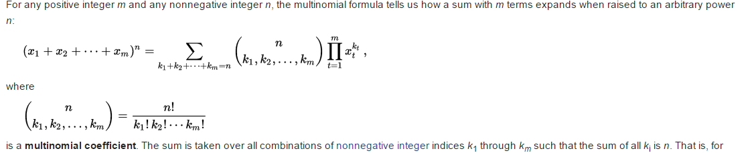

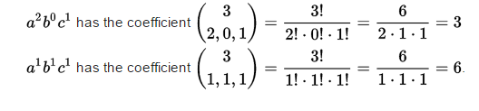

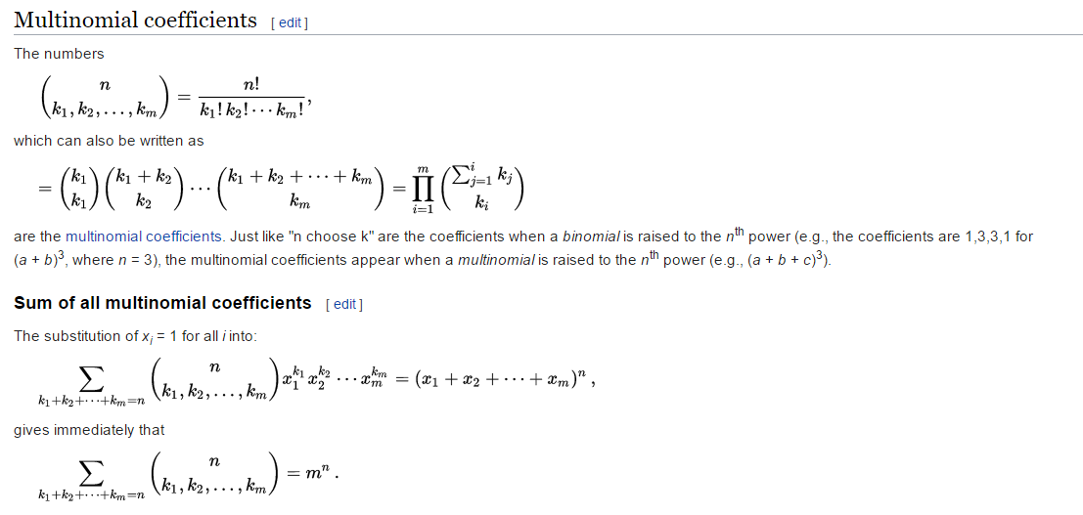

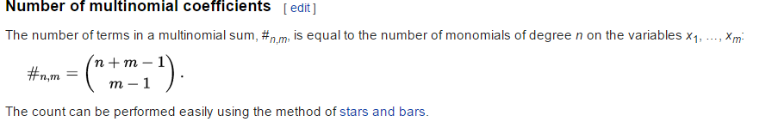

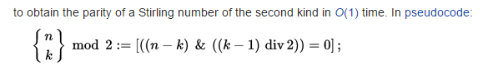

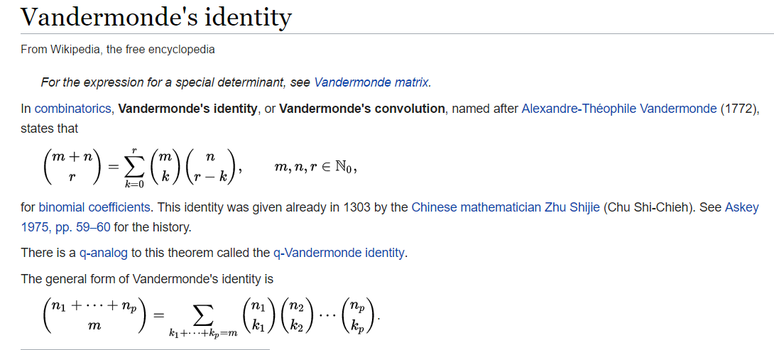

* Let's prove that this number is equal to http://codeforces.com/predownloaded/89/9d/899d8fbe9e58cd0121d8ff7765bc5c5a44e7ba42.png. It's easy to observe that this formula also means the number of ways to match the string with the sequence of zeros and ones of the same length.